**1. creating database**

create database department;

Query OK, 1 row affected

**2. using database**

mysql> use department;

Database changed

**3. create dept table**

mysql> create table Dept(

-> DeptNo int PRIMARY KEY,

-> Dname VARCHAR(30),

-> Loc VARCHAR(30));

Query OK, 0 rows affected

**4. describe table**

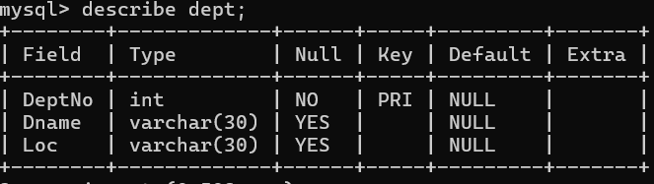

**5. create Emp table**

mysql> CREATE TABLE EMP (

-> Empno int PRIMARY KEY,

-> Ename VARCHAR(100) NOT NULL,

-> sal int,

-> Hire_date date NOT NULL,

-> Commission int NULL,

-> Deptno int NULL,

-> Mgr int ,

-> foreign KEY(deptno) references DEPT(deptno) on delete set NULL,

-> foreign KEY(Mgr) references EMP(Empno) on delete set NULL);

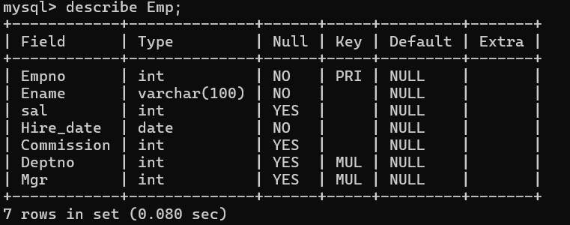

**6. inserting records to Dept**

mysql> INSERT INTO Dept (DeptNo, Dname, Loc) VALUES

-> (10, 'Accounts', 'Bangalore'),

-> (20, 'IT', 'Delhi'),

-> (30, 'Production', 'Chennai'),

-> (40, 'Sales', 'Hyd'),

-> (50, 'Admn', 'London');

Query OK, 5 rows affected (0.365 sec)

Records: 5 Duplicates: 0 Warnings: 0

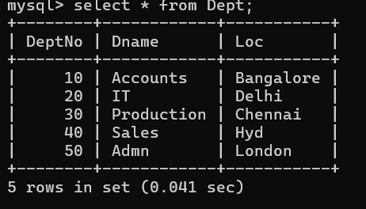

**7. inserting records to Emp table**

INSERT INTO Emp (EmpNo, Ename, Sal, Hire_Date, Commission, Deptno, Mgr) VALUES

(1007, 'Martin', 21000, '2000-01-01', 1040, NULL, NULL);

INSERT INTO Emp (EmpNo, Ename, Sal, Hire_Date, Commission, Deptno, Mgr) VALUES

(1006, 'Dravid', 19000, '1985-01-01', 2400, 10, 1007),

(1005, 'John', 5000, '2005-01-01', NULL, 30, 1006),

(1004, 'Williams', 9000, '2001-01-01', NULL, 30, 1007),

(1003, 'Stefen', 12000, '1990-01-01', 500, 20, 1007),

(1002, 'Kapil', 15000, '1970-01-01', 2300, 10, 1003),

(1001, 'Sachin', 19000, '1980-01-01', 2100, 20, 1003);

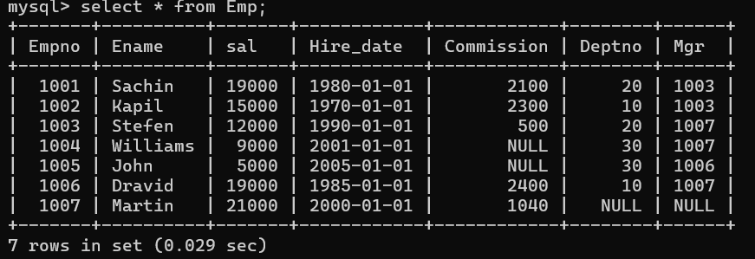

**1)Select employee details of dept number 10 or 30**

select * from Emp where DeptNo=10 or DeptNo=30

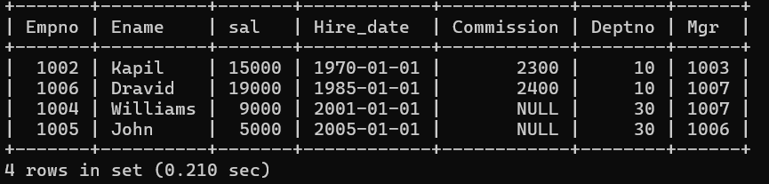

**2)Write a query to fetch all the dept details with more than 1 Employee.**

select * from Dept where

deptno in (select deptno from emp

group by deptno

having count(EmpNo)>1);

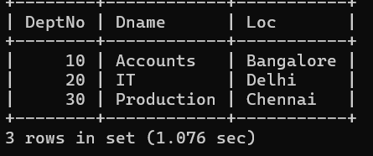

**3)Write a query to fetch employee details whose name starts with the letter “S”**

mysql> select * from Emp

-> where Ename Like "s%";

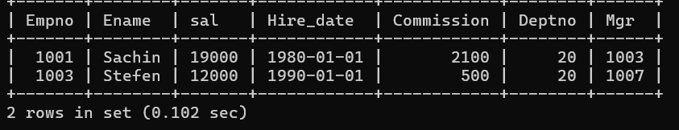

**4)Select Emp Details Whose experience is more than 2 years**

select * ,timestampdiff(year,Hire_Date,curdate()) as experience from Emp

where timestampdiff(year,Hire_Date,curdate())>2;

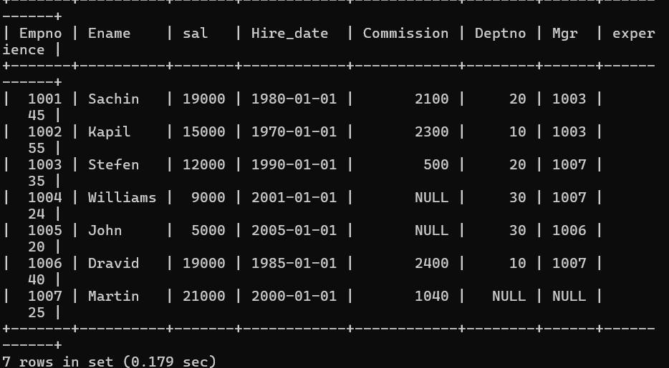

**5)Write a SELECT statement to replace the char “a” with “#” in Employee Name ( Ex: Sachin as S#chin)**

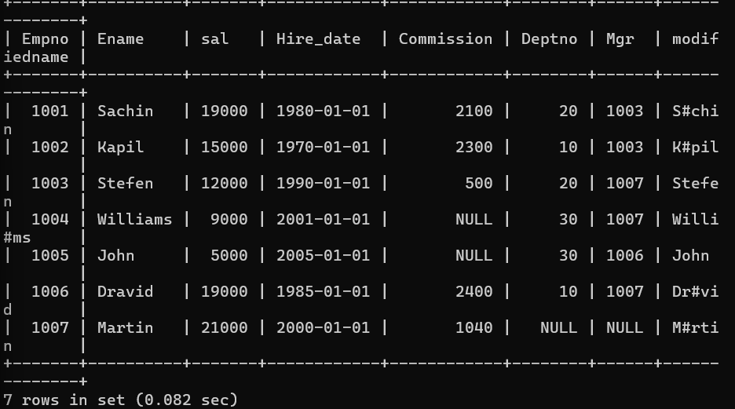

**6)Write a query to fetch employee name and his/her manager name.**

mysql> select e1.ename as employee,e2.ename as manager

-> from emp e1 left join emp e2

-> on e1.mgr=e2.empno;

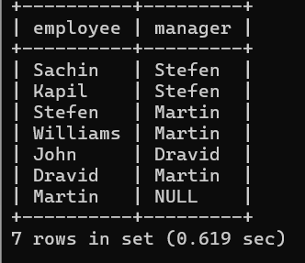

7)Fetch Dept Name , Total Salry of the Dept

mysql> select d.dname as department,sum(e.sal) as salary

-> from emp e join dept d

-> on e.Deptno=d.Deptno

-> group by d.dname;

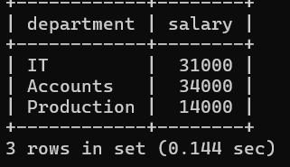

**8)Write a query to fetch ALL the  employee details along with department name, department location, irrespective of employee existance in the department.**

mysql> select e.EmpNo,e.Ename, e.Sal,e.Hire_Date, e.Commission, e.Mgr,d.dname AS Department_Name,d.loc AS Department_Location

-> from emp e right join dept d

-> on e.deptno=d.deptno;

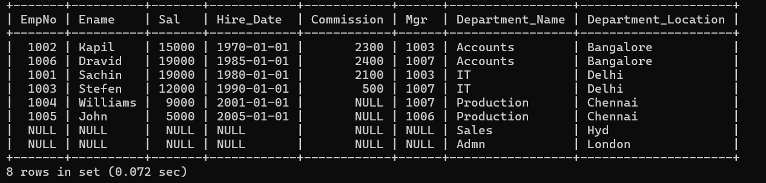

**9)Write an update statement to increase the employee salary by 10 %**

mysql> select * from emp;

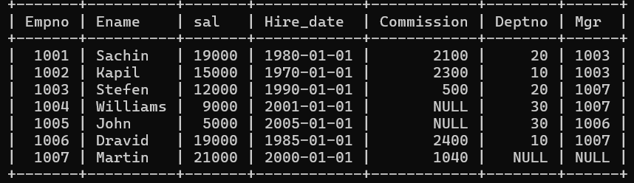

mysql> update Emp

-> set sal=sal*1.1;

mysql> select * from emp;

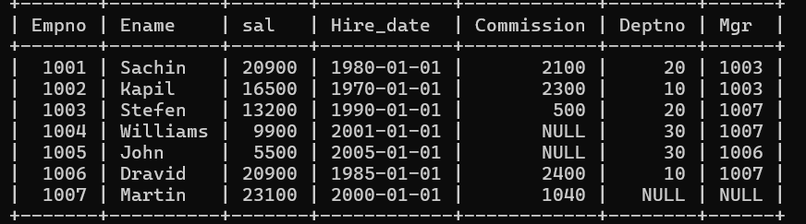

**10)Write a statement to delete employees belong to Chennai location.**

mysql> delete from emp

-> where deptno in(select deptno from dept where loc="Chennai");

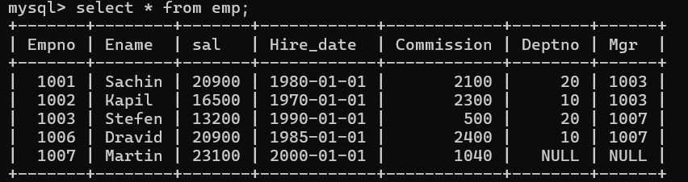

**11)Get Employee Name and gross salary (sal + comission).**

mysql> select ename,(sal+ coalesce(Commission,0))as gross_salary from emp;

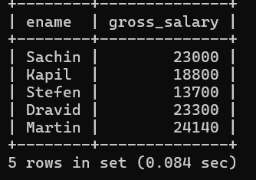

**12) Increase the data length of the column Ename of Emp table from  100 to 250 using ALTER statement**

mysql> alter table emp

-> modify column ename VARCHAR(250);

mysql> desc emp;

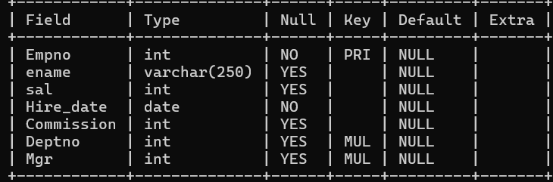

**13)Write query to get current datetime**

mysql> select now() as current_datetime;

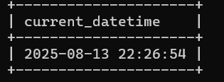

**14)Write a statement to create STUDENT table, with related 5 columns**

mysql> create table student(

-> usn varchar(10) primary key,

-> sname varchar(100) not NULL,

-> sage int not NULL,

-> class int ,

-> section varchar(1)

-> );

mysql> desc student;

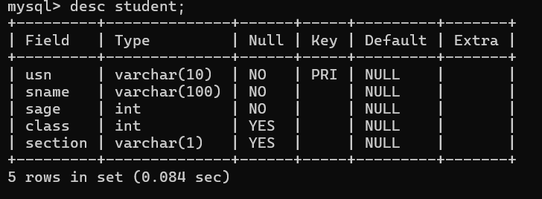

**15) Write a query to fetch number of employees in who is getting salary more than 10000**

mysql> select count(EmpNo) as Employee_count from Emp

-> where sal>10000;

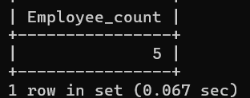

**17)Write a query to fetch minimum salary, maximum salary and average salary from emp table.**

mysql> select min(sal) as Minimum_Salary,

-> max(sal) as Maximum_Salary,

-> avg(sal) as Average_salary from emp;

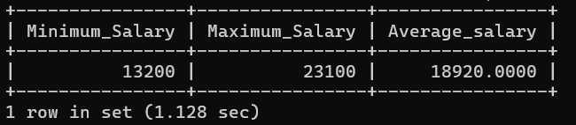

**17)Write a query to fetch number of employees in each location.**

mysql> select d.loc as location, count(e.empno) as Employee_count

-> from emp e right join dept d

-> on e.Deptno=d.Deptno

-> group by d.loc;

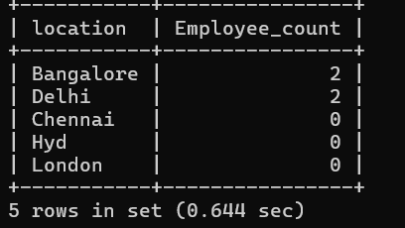

**18)Write a query to display emplyee names in descending order**

mysql> select ename from Emp

-> order by ename Desc;

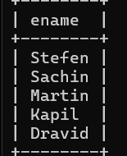

**19)Write a statement to create a new table(EMP_BKP) from the existing EMP table.**

mysql> create table EMP_BKP as

-> select * from emp;

mysql> select * from EMP_BKP;

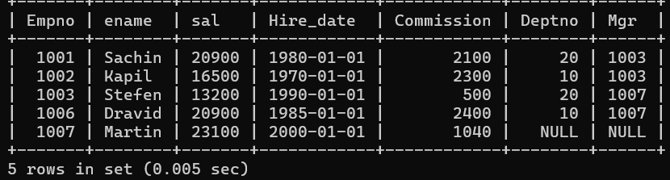

**20) Write a query to fetch first 3 characters from employee name appended with salary.**

mysql> select concat(left(ename,3),sal) as Employee_info from emp;

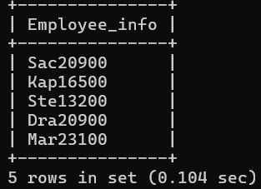

**21)Get the details of the employees whose name starts with S**

mysql> select * from Emp

-> where ename like "s%";

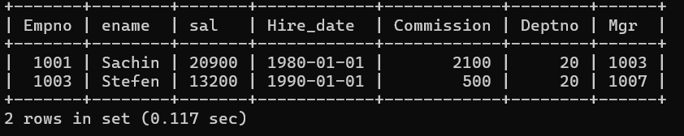

**22)Get the details of the employees who works in Bangalore location.**

mysql> select * from emp e right join dept d on d.Deptno=e.Deptno

-> where d.loc="Bangalore";

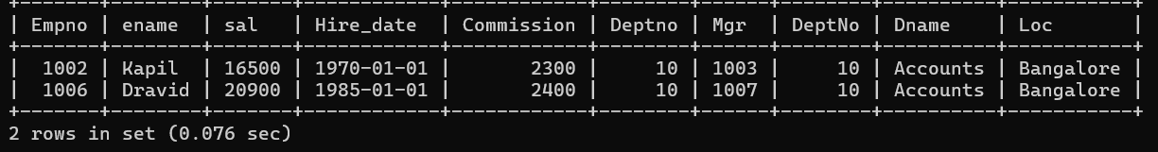

**23) Write the query to get the employee details whose name started within any letter between A and K**

mysql> select * from Emp

-> where ename between "A%" and "k%";

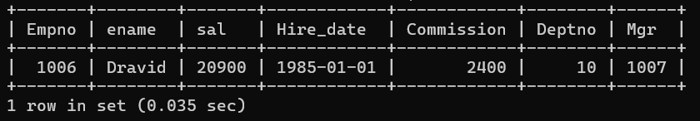

**24)Write a query in SQL to display the employees whose manager name is Stefen.**

mysql> select e1.* from emp e1 join emp e2

-> on e1.Mgr =e2.empno

-> where e2.ename="Stefen";

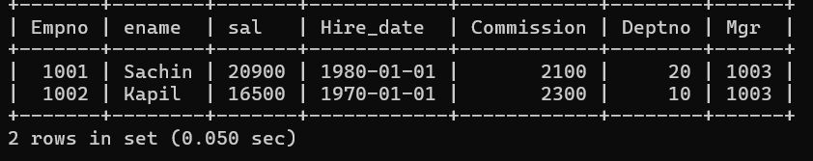

**25) Write a query in SQL to list the name of the managers who is having maximum number of employees working under him.**

mysql> select e2.ename as Manager_Name, count(e1.EmpNo) as Employee_Count

-> from emp e1 join emp e2 on e1.Mgr = e2.EmpNo

-> group by e2.Ename

-> having count(e1.EmpNo) = (

-> select max(Employee_Count)

-> from (

-> select count(EmpNo) as Employee_Count

-> from Emp

-> where Mgr is not NULL

-> group by Mgr

-> ) as ManagerCounts

-> );

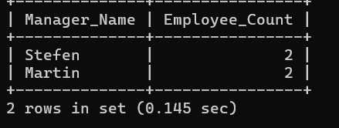

**26) Write a query to display the employee details, department details and the manager details of the employee who has second highest salary.**

mysql> select EmpNo, Ename, Sal, DeptNo, Mgr

-> from Emp

-> order by Sal DESC

-> LIMIT 1 OFFSET 1;

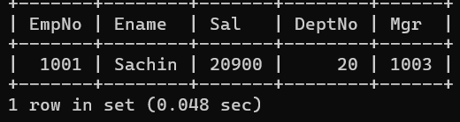

**27) Write a query to list all details of all the managers.**

mysql> select e.* from emp e

-> where e.empno IN

-> (select distinct Mgr from emp

-> where mgr is not null

-> );

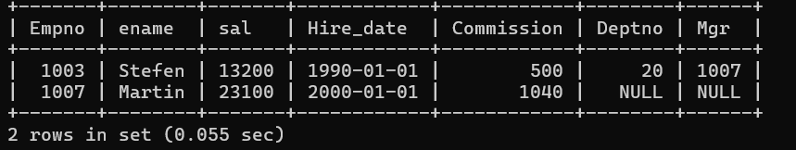

**28) Write a query to list the details and total experience of all the managers.**

mysql> select e.* ,timestampdiff(year,Hire_Date,curdate()) as Experience from emp e

-> where e.empno IN (select distinct Mgr from emp where mgr is not null);

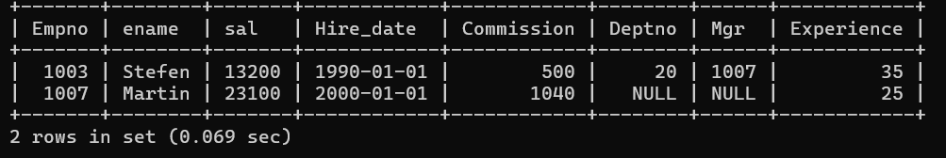

**29) Write a query to list the employees who is manager and takes commission less than 1000 and works in Delhi.**

mysql> select DISTINCT e.*

-> from Emp e

-> join Dept d on e.DeptNo = d.DeptNo

-> where e.EmpNo in (select distinct Mgr from Emp where Mgr is not null)

-> and e.Commission < 1000

-> and d.Loc = 'Delhi';

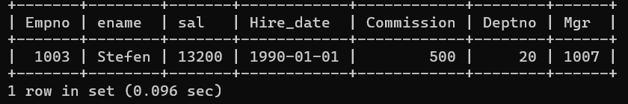

**30) Write a query to display the details of employees who are senior to Martin.**

mysql> select * from emp

-> where Hire_Date<(select Hire_Date from emp where Ename='Martin');

